**Engineer Design Contest: SEL-FT50 and SEL-FR12**

Example Design Entry Form

Email design entries to FT50FR12designcontest@selinc.com.

**Designer (individual or team)**: John Smith and Jane Smyth

**Email address**: johnsmith@myutility.com, janesmyth@myutility.com

**Utility/company**: My Utility

**Charity or school for prize donation**: University of State

**Problem statement**:

Utilities are often unwilling to reclose on faults near an underground-to-overhead transition because they do not want to reclose on underground faults. Underground faults are typically permanent, and reclosing on permanent faults stresses cables and connectors. Therefore, it is important to know the precise fault location to choose the best protection scheme.

**SEL-FT50 and SEL-FR12 application**:

SEL-FT50 Transmitters can be placed at the beginning of the overhead span. If an SEL‑FT50 detects a fault, it sends a message to the SEL-FR12 Receiver connected to the feeder relay. The relay can change its protection scheme from blocking to allow reclosing to clear the temporary overhead fault.

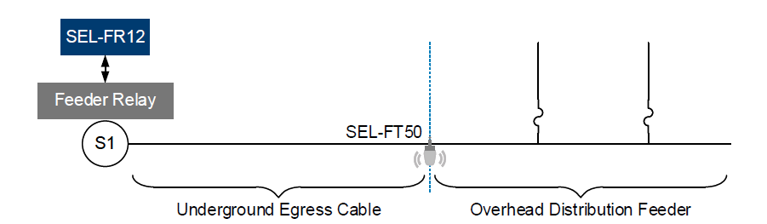

**Improvement(s) to the power system**:

This fine-tuned selectivity approach reduces outages and improves SAIDI metrics.